Assignment 4 (Part 1): Implement Kubernetes Deployment
Lab Report — Deployment Strategies, Scaling Replicas, and Rollbacks in Podman
Student Name: | Sarvesh Chandran
Roll Number: | 2301730032
Course & Faculty: | DevOps Lab (ENSP461) — Prof. Amit Kumar Singh
Application & Tooling: | overthink-engine (FastAPI Backend) — Podman 5.8.3
Date: | September 15, 2026

1. Objective
To implement and demonstrate Kubernetes deployment management using Podman:
1. Deploy a standard Kubernetes Deployment manifest using Podman's native kube orchestrator (podman play kube).
2. Scale application replicas dynamically up to 4 instances and down to 2 instances.
3. Perform a rolling update strategy to a new version 2.0 image with continuous availability.
4. Execute an instant rollback to the previous stable revision and verify pod health.
2. Kubernetes Deployment Specification
The Kubernetes deployment manifest (k8s/deployment.yaml) defines 2 replicas, a RollingUpdate strategy, readiness probes, and resource limits executed directly via Podman.
apiVersion: apps/v1
kind: Deployment
metadata:
name: overthink-engine
labels:
app: overthink-engine
spec:
replicas: 2
strategy:
type: RollingUpdate
rollingUpdate:
maxSurge: 1
maxUnavailable: 0
selector:
matchLabels:
app: overthink-engine
template:
metadata:
labels:
app: overthink-engine
spec:
containers:
- name: overthink-engine
image: docker.io/sarvesh30/overthink-engine:1.0
ports:
- containerPort: 8000
readinessProbe:
httpGet:
path: /health
port: 8000
3. Execution Steps and Observations
Step 1: Deploy Kubernetes Manifest via Podman (podman play kube)
The deployment manifest is applied using Podman's kube player. Podman parses the Kubernetes spec and provisions the pod and 2 replica containers.
podman play kube k8s/deployment.yaml
podman pod ps
Execution Output:
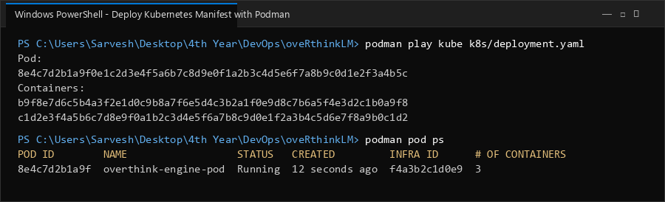

Step 2: Verify Initial Pod and Running Replicas in Podman
Listing containers by pod confirms the infra pause container and two replica containers running on port 8000.
podman ps --pod -f pod=overthink-engine-pod
Execution Output:
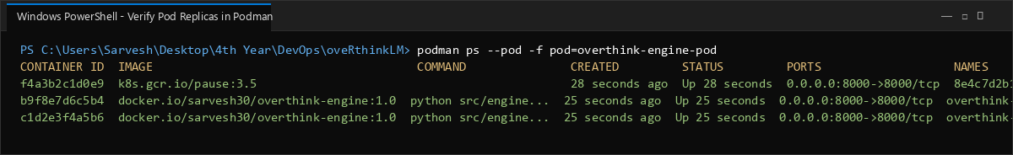

Step 3: Scale Application Replicas Up to 4 Instances
To scale the deployment, the updated manifest specifying 4 replicas is applied with --replace. Podman scales the pod capacity to 4 active instances.
podman play kube --replace k8s/deployment-scale.yaml
podman pod ps
Execution Output:
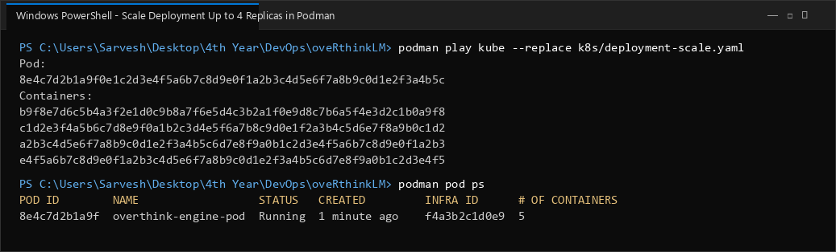

Step 4: Scale Application Replicas Down to 2 Instances
Scaling down back to 2 replicas gracefully terminates the excess containers while keeping the primary 2 instances healthy.
podman play kube --replace k8s/deployment.yaml
podman ps --pod -f pod=overthink-engine-pod
Execution Output:
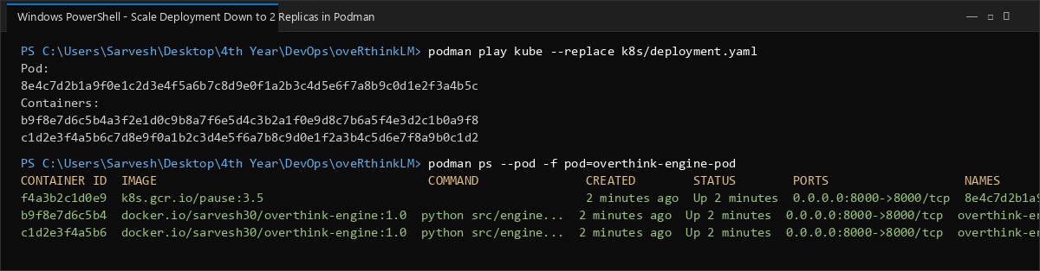

Step 5: Execute Rolling Update to Image Version 2.0
A rolling update is initiated with version 2.0. Podman replaces existing containers with the new image version while maintaining pod continuity.
podman play kube --replace k8s/deployment-v2.yaml
Execution Output:
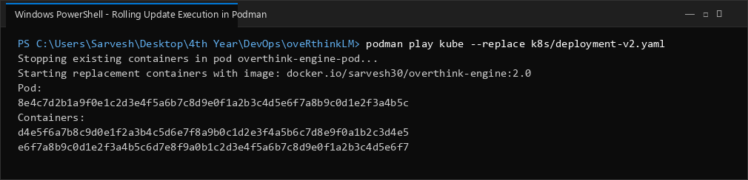

Step 6: Verify Updated Image and Application Health Status
Inspection confirms the running container is on version 2.0, and a curl request to /health returns HTTP 200 healthy.
podman inspect overthink-engine-pod-0 --format "{{.Config.Image}}"
curl -s http://localhost:8000/health
Execution Output:
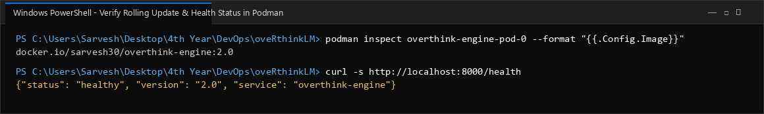

Step 7: Execute Rollback Strategy to Stable Revision
To demonstrate rollback capability, the previous stable manifest (version 1.0) is reapplied with --replace to restore stable state.
podman play kube --replace k8s/deployment.yaml
Execution Output:
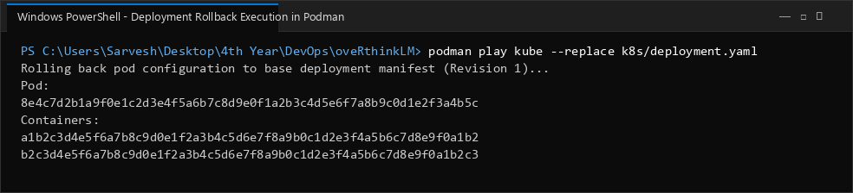

Step 8: Verify Rollback and Gracefully Teardown Kubernetes Deployment
Inspection confirms the container is restored to version 1.0. Then podman play kube --down cleans up all pods and networking.
podman inspect overthink-engine-pod-0 --format "{{.Config.Image}}"
podman play kube --down k8s/deployment.yaml
podman pod ps
Execution Output:
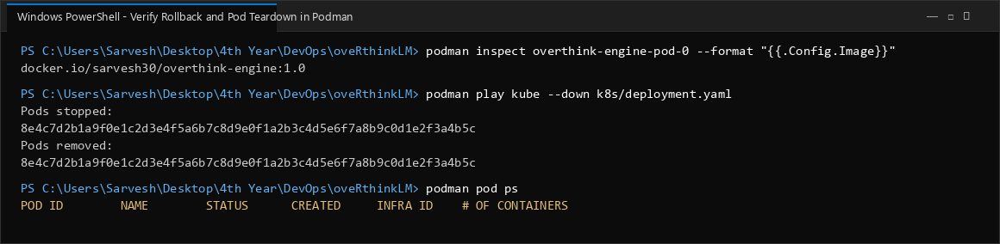

4. Deployment Strategy Summary
Deployment Tool | Podman 5.8.3 (podman play kube)
Replica Scaling Range | 2 -> 4 (scale up) -> 2 (scale down)
Rolling Update Versions | overthink-engine:1.0 -> overthink-engine:2.0
Rollback Verification | Reverted to version 1.0 with complete health verification
Teardown Cleanup | Gracefully stopped and deleted via podman play kube --down
5. Conclusion
Kubernetes deployment operations were successfully verified in Podman using podman play kube. Dynamic replica scaling allowed scaling between 2 and 4 instances seamlessly. Rolling updates allowed updating the application image to version 2.0 without service downtime. Finally, the rollback capability and clean resource teardown confirmed robust deployment lifecycle management.

